Critical Occupational Science: Implications for Occupational Therapy Practice
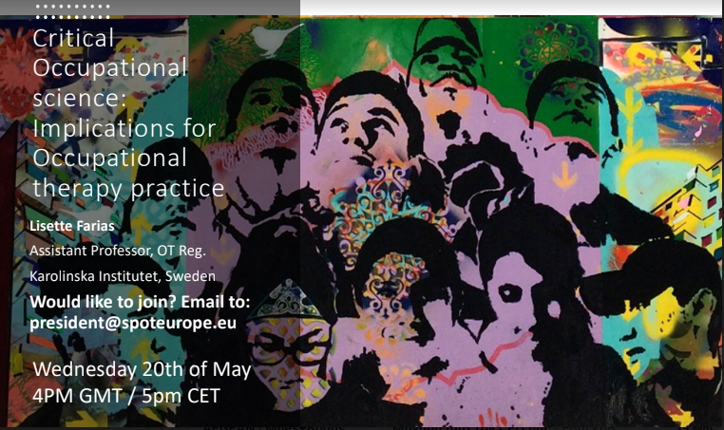
Topic: Critical Occupational Science
Organized by SPOTeurope
Hosted by Lisette Farias

Introduction:
Lisette Farias is an Assistant Professor at Karolinska Institute in Sweden as well as a researcher. She did her bachelor’s degree in France, which lasted 5 years, her masters in Europe (European Master of Science in Occupational Therapy) and her doctorate in a totally different country which means she has experienced a lot of different cultures. When she first went to Sweden for her studies, she said she felt like she was an immigrant, however, she was lucky enough to get a job quickly, which helped her a lot, but is very uncommon. Now she is working with people who experience social and economic difficulties, besides her duties as a lecture.
First of all, we had a talk about how privileged many people are to have access and be allowed to participate in occupations and that they should not take everyday occupations, or any occupation, for granted. This shows how easy it is to take things for granted when a lot of people struggle to cope with even less.
Key points of the presentation:
- The common elements that characterize critical occupational science (OS)
- The potential contributions of a critical perspective to practice and the understanding of occupation and occupational therapy
Background:
To present an overview of all the progress of OT and OS, Lisette made a historical line. At first, during the 18th and 19th centuries, all patients were locked away and treated very poorly. Later on, some occupation-based improvements were made but after the second World War they went back to using the medical model, therefore, most of the progress was lost.
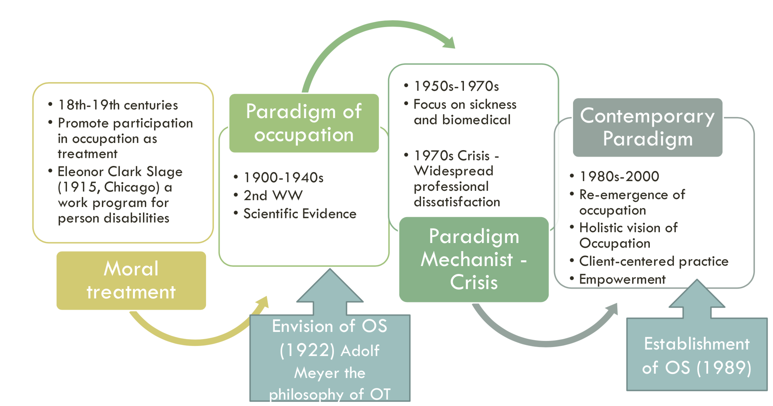
After that, a paradigm shift appeared, and everyone started talking about occupation based and client centered interventions. Afterwards, occupational therapy could be applied to cases despite of the existence of an illness or not.
Further on, literature began to expand; models and theories were developing until ±2005. After this, OT’s started to revise them and made some changes since this would be better applied, based on practical facts. Last but not least, soon after that people started joining the movement for the development of occupational science.
Before moving on to the definition of Critical Occupational Science, Lisette talked about how the occupational injustice could lead anyone into thinking how occupations are the means to therapy. For some additional Lisette suggests the following books: OT without borders and Occupational Science: Society, Inclusion, Participation.
Critical occupational science:
Critical Social Theory is an umbrella term which includes, among others, critical occupational science (e.g. critical race, governmentality etc.)
It consists of the following terms:
- Focus on occupation
- Critical social theory – critical perspectives
- Reality and knowledge
- Power relations
- Critique of ‘common sense’, ‘taken for granted’
- (re)formulate practices - transformation
For example, it seems normal for a person that lives in Europe, that a woman can go for a walk at 9 pm but elsewhere it might be ethically or politically forbidden for her to do so.
Critical occupational science:
- “Dominant focus on occupations that can restore or maintain good health, seen as something positive and productive” (Twinley & Addidle, 2012)
- “Tendency to privileging those people that engage in occupations as “productive” or health – while marginalizing others” (Kiepek et. al, 2013)
- “Critical occupational approach locates occupation as “a site of knowledge production, that is, active political sites where meanings are generated and contested” (Njemelesani et al., 2013, p.12)”.
- “Occupation as “always a product of history, society and agency, and as continually shaped in relations of power” (Laliberte Rudma, 2014, p.381)”
Personal example of Lisette; Where she was born, people use to run only as a gateway, but when she moved to Sweden, she saw that people run as a hobby every hour of the day. So, the context actually defines and shapes the occupation.
Examples of implications:
- Expanding the conceptualization of occupation, e.g. occupation as situated, occupation as residing within the individual, occupational choice
- Examining occupations as resistance
- Challenging the categorization of occupations that perpetuates dominant ideal ways of living
- Avoiding blaming individual and groups for what is frames as irresponsibility for not doing the “right” occupations
- Judging indigenous parent–infant play against Western normative standards can increase the likelihood of blaming parents as neglectful and labelling children as ‘at risk’
D
Following up, there was a conversation about how the support of the environment enables occupation and how access really values in terms of enabling occupation.
Also Lisette shared information about the inequality of participation in occupations.
She then referred to the fact about how we OTs usually focus on “good” occupations and avoid the “bad” ones and that we should include them as well if they had been an essential part of a person’s lifestyle, but in a much brighter none harmful way.
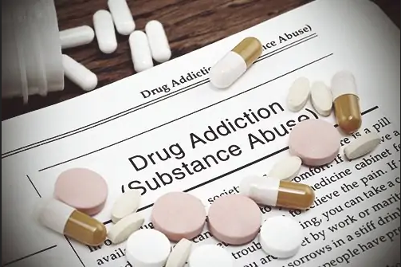
The students were reminded that OTs also have to work with every single group and not just alongside people with psychological, social, financial or physical impairments. For example, with drug addicts, prisoners to be freed etc.
In other words occupational science is a great help to OTs to see which group of persons have been left out by OTs.
She also pointed out that we always have to see occupation in a context and not on its own.
Then the implications of occupational science, expanding the conceptualization of occupation and examining occupation as resistance, were brought up.
Group projects:
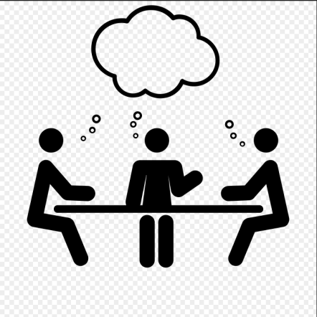
The participants were separated into smaller groups of 4-6 people and had to talk about one “bad occupation” and the group of persons who are marginalized just by engaging in it.
The first group came up with the occupation “smoking tobacco” and clarified that in many countries it is not a big deal but in others it is reprehensible. It was also mentioned that in the same country or city people would be judged for smoking depending on their cultural background or social/financial status, maybe even age.
The second group talked about healthy eating and that some foods are either difficult to find or maybe too expensive for people to buy, so they are just forced to eat less healthy and more junk food since its cheaper.
The third group spoke about alcoholism and how it is okay for younger people to be addicted to it but when for example parents are addicted to drinking the same amount such as a teenager, they are shamed for it. This opened the discussion about stereotype and typically norms for specific groups.
The fourth and final group referred to sex workers and prostitution, and how people who do it are shamed for it.
The last thing Lisette pointed out, before the session was finished, that OTs have to always look critical upon occupational therapy so as to improve it and provide better services. And that’s a part of critical occupational science.
After this final word, the session has ended.
SPOTeurope is very grateful for everyone who participated and a big thank you to Lisette for hosting this session!

