Summary of 1st video chat within the #StayHome campaign
Being an OT student in times of COVID-19
Chaired by: Vanessa Röck (Student Board Member from SPOTeurope and ENOTHE), Austria
Special guest: Mike Jarrey, Hogeschool Artevelde/Belgium

The first week of our #StayHome campaign dealt with the current situation the population is facing and more specifically, how it is at the moment to be an OT student in times of COVID-19. This was also the focus of yesterday’s video chat, which started with some thoughts from Mike Jarrey. Afterwards, there has been an exchange about our current situation, discussing about some background information from occupational science and sharing ideas how to handle the situation and make the best out of it.
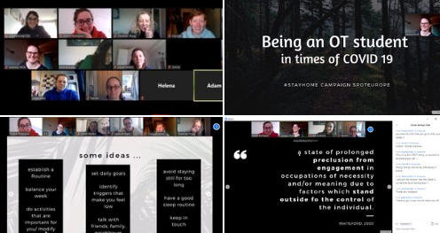
In the beginning, Mike Jarrey has shared some inspirational thoughts about how to start with an occupational perspective, as further outlined in the book from Wilcock (1998). How this current enforced change in context causes a disruption and/or further deprivation in people’s doing. But that we as OT students can also see this as an opportunity to learn, to think about how occupational therapy can respond and to work on our occupational lens by experience a living example. He emphasized, how important it is to consider the impact of context and how these outside influences can interfere with engagement and/or participation in occupations and referred to a relatively new concept of occupational consciuousness (Ramugondo, 2015) and a keynote from the WFOT congress 2018 in South Africa (https://www.youtube.com/watch?v=S96IIytPG9I&t=2206s). Thank you very much for taking time and igniting some ongoing thoughts!
After Mike Jarrey had to leave for another meeting, we first used the time for getting to know each other. Therefore, we briefly introduced SPOTeurope and then had an introduction round to know the names and which university/country participants are studying in.
Afterwards, we were going back to the case study with which we have started the week, as well as a short theoretical background about the power of doing and consequences when occupations are at risk. It was discussed, whether we see this current situation as disruption and/or deprivation – talking about aspects as e.g. degree of control of the individual, time aspect.
This was followed by finding solutions to the case study and what we could suggest this student and use for ourselves. Some ideas were e.g.: organize tasks one must complete in a day, find new occupations or adapt them. For example, instead of going to a concert in real life, watch one with peers via social media. It was also discussed that we have to be aware of the screen time since everything is now online and therefore think about occupations without screen.
As some of you might have seen on our social media, we were unfortunately interrupted because our meeting was interrupted since some random people logged in and we were not able to kick them out. However, we did not let bring ourselves down and continued after a 30 minutes disruption. Nevertheless, we have learned the lesson and to avoid this, we will continue with the video chats with pre-registrations and maybe password.
In conclusion, except from this interruption, we were happy to have had a first thriving video chat and are looking forward to sharing thoughts on another topic next week on Friday, 5p.m (C.E.T). We are looking forward to seeing you there – please let us know if you would like to take part!

References:
Ramugondo, E. (2015) Occupational Consciousness, Journal of Occupational Science, 22:4, 488-501, DOI: 10.1080/14427591.2015.1042516
Further references are in the presentation (add link here)

